**PRABAL GHOSH ROLL- AM.SC.P2CSC20040**

**SEMANTIC WEB –SPARQL ASSIGNMNET_code_done_by_me**

Assignment SPARQL

Create owl file to describe the following using Protégé:

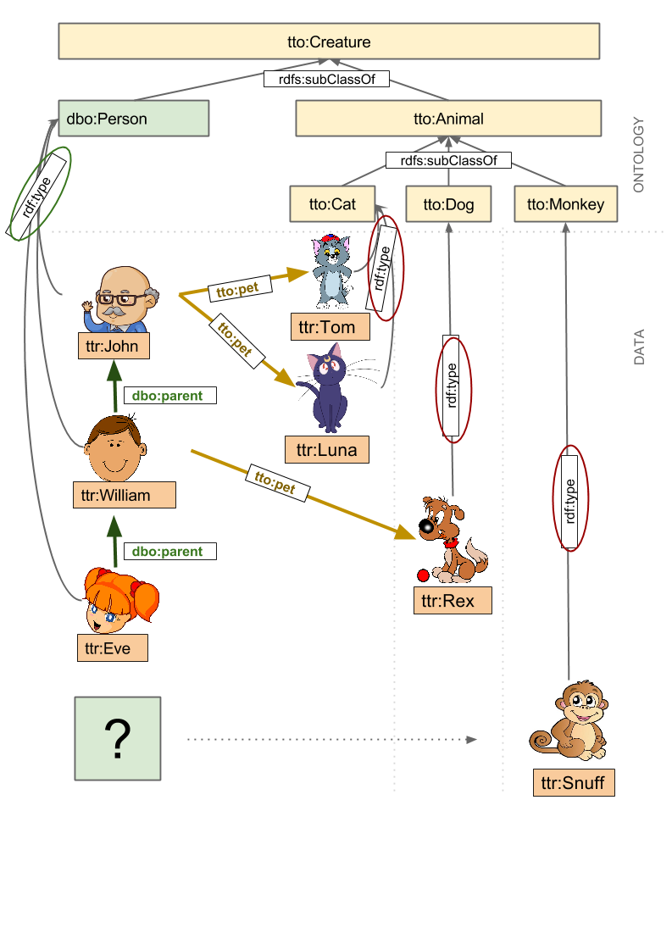

1.

Run the queries in protege for the questions given in the site https://sparql

playground.sib.swiss/ numbered - 200 till 209 using the owl file you have created. Then

try to run 220 (by filling in the *** blanks). Take a screenshot of the SPARQL code box

& the output and paste it in a word file for each question. (1.1 to 1.11)

2.

Write a SPARQL statement to find out: How many triplets are contained in the

dataset? Take a screenshot of the SPARQL code box and the output and paste in the

word file.

3.

Write a SPARQL statement to find out: How many instances of a “Animal” class are

declared? Take a screenshot of the SPARQL code box and the output and paste

below.

**SOLUTION:**

@prefix owl: <http://www.w3.org/2002/07/owl#> .

@prefix rdf: <http://www.w3.org/1999/02/22-rdf-syntax-ns#> .

@prefix rdfs: <http://www.w3.org/2000/01/rdf-schema#> .

@prefix :<http://example.org/prabal/ontology#> .

@prefix xsd: <http://www.w3.org/2001/XMLSchema#> .

#class

:Creature a owl:Class ;

rdfs:label "creature"^^xsd:string.

:Person a owl:Class ;

rdfs:subClassOf :Creature .

:Animal a owl:Class ;

rdfs:label "animal"^^xsd:string ;

rdfs:subClassOf :Creature .

:Cat a owl:Class ;

rdfs:label "cat"^^xsd:string ;

rdfs:subClassOf :Animal .

:Dog a owl:Class ;

rdfs:label "dog"^^xsd:string ;

rdfs:subClassOf :Animal .

:Monkey a owl:Class ;

rdfs:label "monkey"^^xsd:string ;

rdfs:subClassOf :Animal .

#property

:parent a rdf:ObjectProperty ;

rdfs:domain :Person ;

rdfs:range :Person .

:pet a rdf:ObjectProperty ;

rdfs:domain :Person ;

rdfs:label "domestic animal"^^xsd:string ;

rdfs:range :Animal .

:sex a owl:DatatypeProperty ;

rdfs:domain :Creature ;

rdfs:label "sex"^^xsd:string ;

rdfs:range xsd:string .

:name a owl:DatatypeProperty ;

rdfs:domain :Creature ;

rdfs:label "name"^^xsd:string ;

rdfs:range xsd:string .

# individuals

:John a :Person ;

:name "John"^^xsd:string ;

:pet :Luna , :Tom ;

:sex "male"^^xsd:string .

:William a :Person ;

:parent :John ;

:name "William"^^xsd:string ;

:pet :Rex ;

:sex "male"^^xsd:string .

:Eve a :Person;

:parent :William ;

:name "Eve"^^xsd:string ;

:pet :Snuff ;

:sex "female"^^xsd:string .

:Tom a :Cat ;

:name "Tom"^^xsd:string ;

:sex "male"^^xsd:string .

:Luna a :Cat;

:name "Luna"^^xsd:string ;

:sex "female"^^xsd:string .

:Rex a :Dog ;

:name "Rex"^^xsd:string ;

:sex "male"^^xsd:string .

:Snuff a :Monkey ;

:name "snuff"^^xsd:string ;

:sex "male"^^xsd:string .

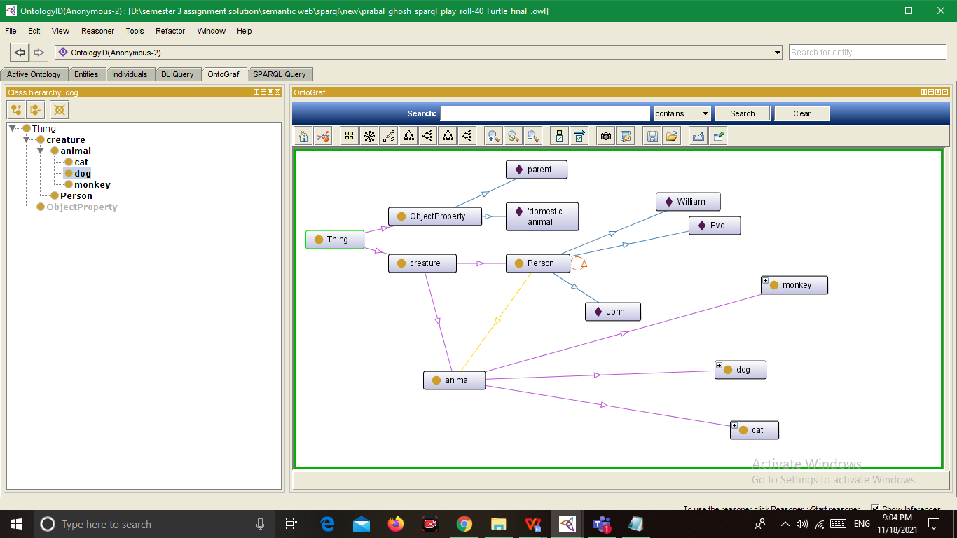

**SELECT DISTINCT * WHERE {**

**?s ?p ?o**

**} LIMIT 10**

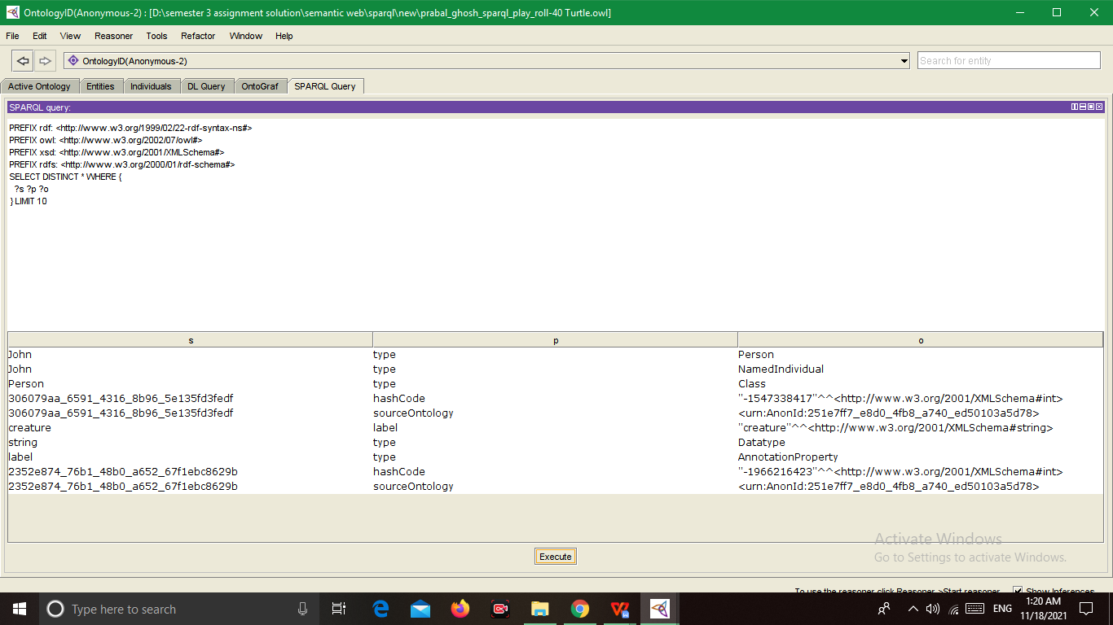

200)

PREFIX rdf: <http://www.w3.org/1999/02/22-rdf-syntax-ns#>

PREFIX owl: <http://www.w3.org/2002/07/owl#>

PREFIX xsd: <http://www.w3.org/2001/XMLSchema#>

PREFIX rdfs: <http://www.w3.org/2000/01/rdf-schema#>

prefix :<http://example.org/prabal/ontology#>

select ?thing where {

?thing rdf:type :Person

}

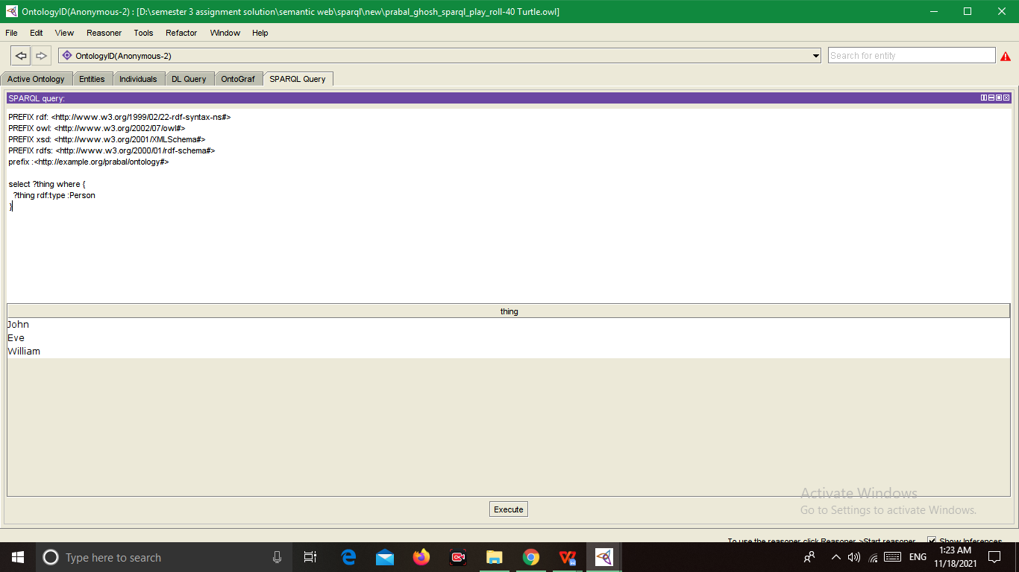

201)

PREFIX rdf: <http://www.w3.org/1999/02/22-rdf-syntax-ns#>

PREFIX owl: <http://www.w3.org/2002/07/owl#>

PREFIX xsd: <http://www.w3.org/2001/XMLSchema#>

PREFIX rdfs: <http://www.w3.org/2000/01/rdf-schema#>

PREFIX : <http://example.org/prabal/ontology#>

select ?thing where {

?thing :sex "female"^^xsd:string .

}

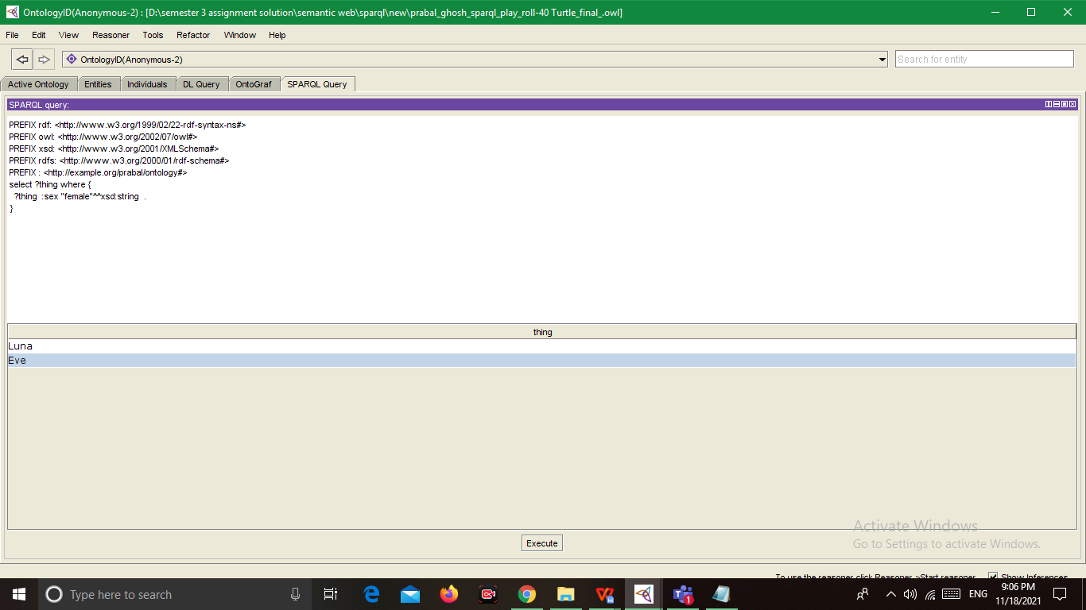

201)

select ?thing ?x where {

?thing :sex ?x .

}

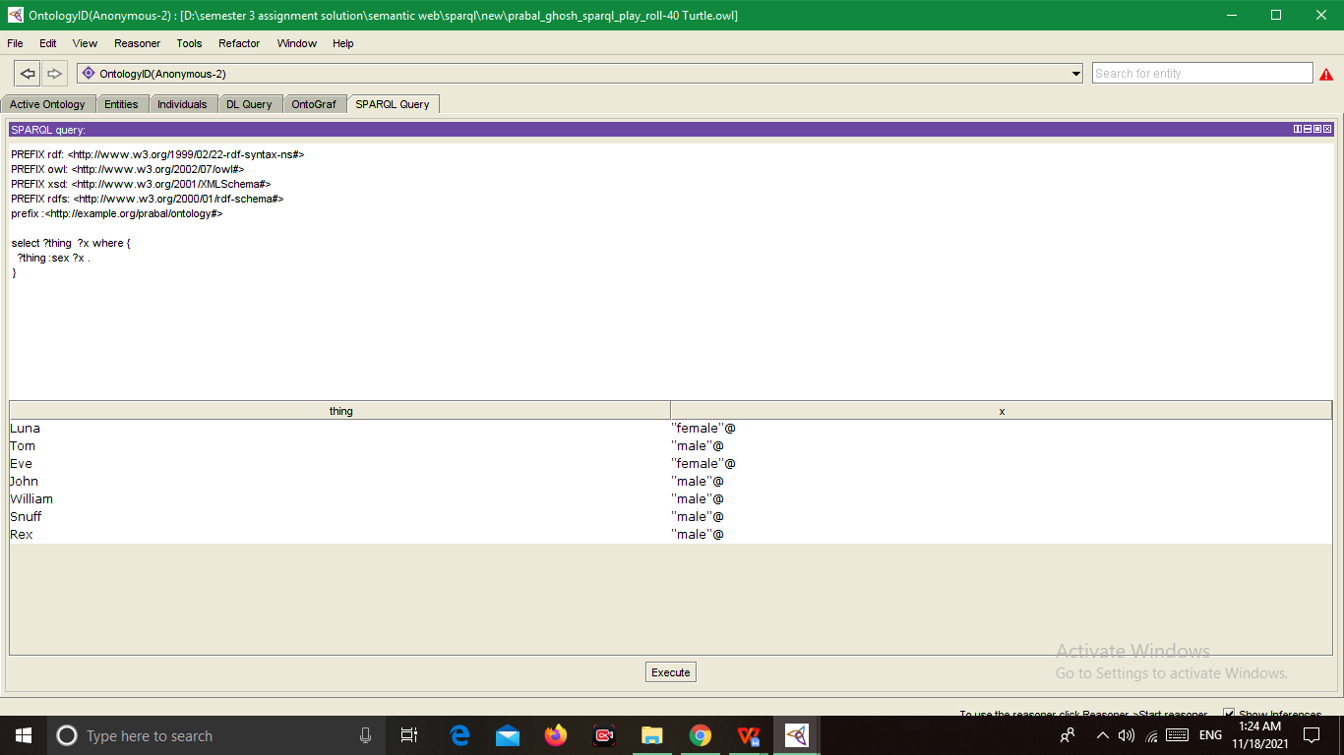

202)

PREFIX rdf: <http://www.w3.org/1999/02/22-rdf-syntax-ns#>

PREFIX owl: <http://www.w3.org/2002/07/owl#>

PREFIX xsd: <http://www.w3.org/2001/XMLSchema#>

PREFIX rdfs: <http://www.w3.org/2000/01/rdf-schema#>

PREFIX : <http://example.org/prabal/ontology#>

select ?thing where {

?thing a :Person .

?thing :sex "female"^^xsd:string .

}

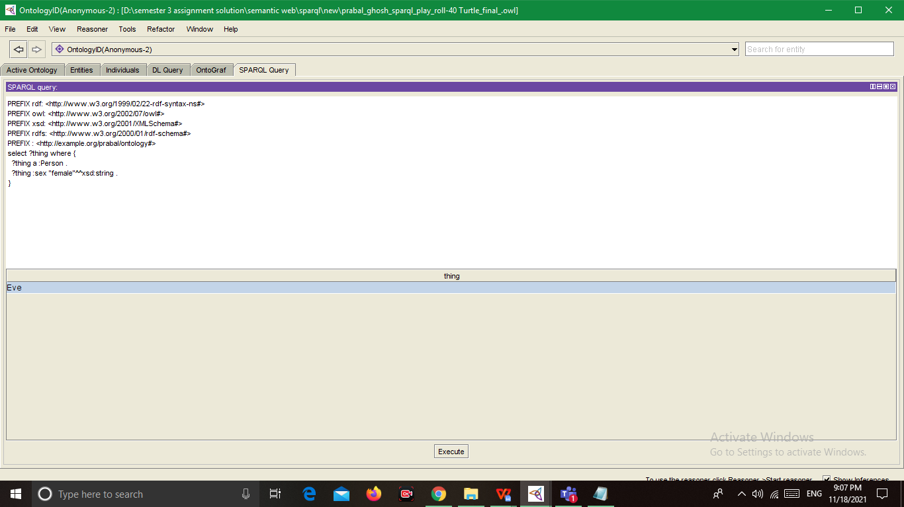

202)

select ?s ?x where {

?s a :Person ;

:sex ?x

}

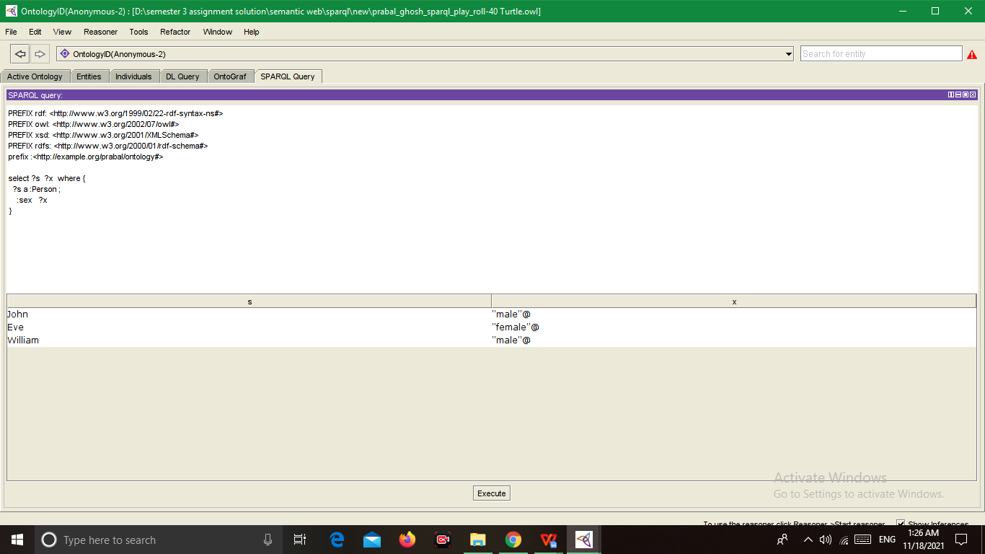

204)

PREFIX rdf: <http://www.w3.org/1999/02/22-rdf-syntax-ns#>

PREFIX owl: <http://www.w3.org/2002/07/owl#>

PREFIX xsd: <http://www.w3.org/2001/XMLSchema#>

PREFIX rdfs: <http://www.w3.org/2000/01/rdf-schema#>

PREFIX : <http://example.org/prabal/ontology#>

select ?thing ?sex where {

?thing :sex ?sex .

}

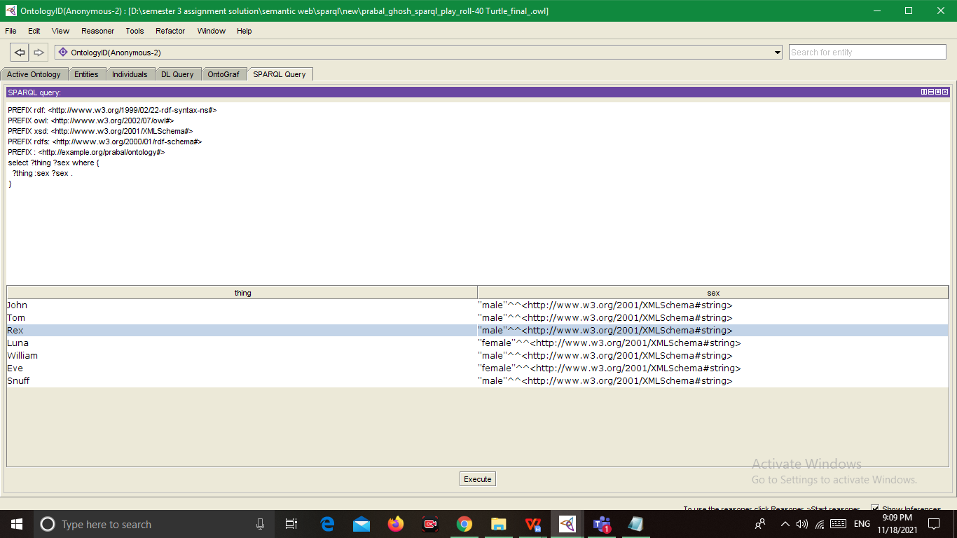

204)

select ?thing ?sex where {

?thing :sex ?sex .

}

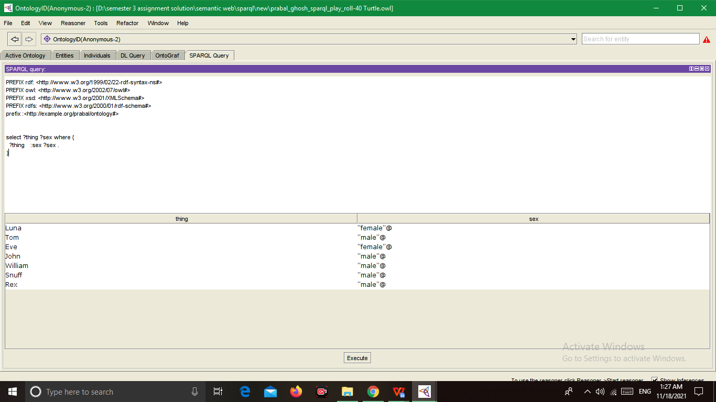

206)

select ?person ?pet where {

?person rdf:type :Person ;

:pet ?pet .

}

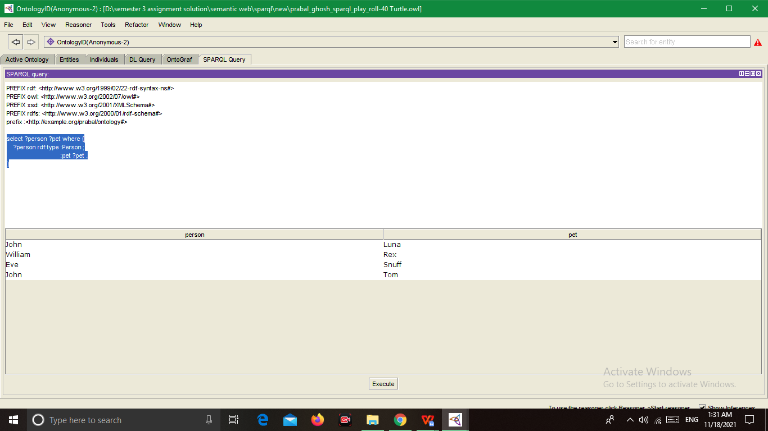

207)

select ?person ?pet where {

?person rdf:type :Person .

optional {?person :pet ?pet }.

}

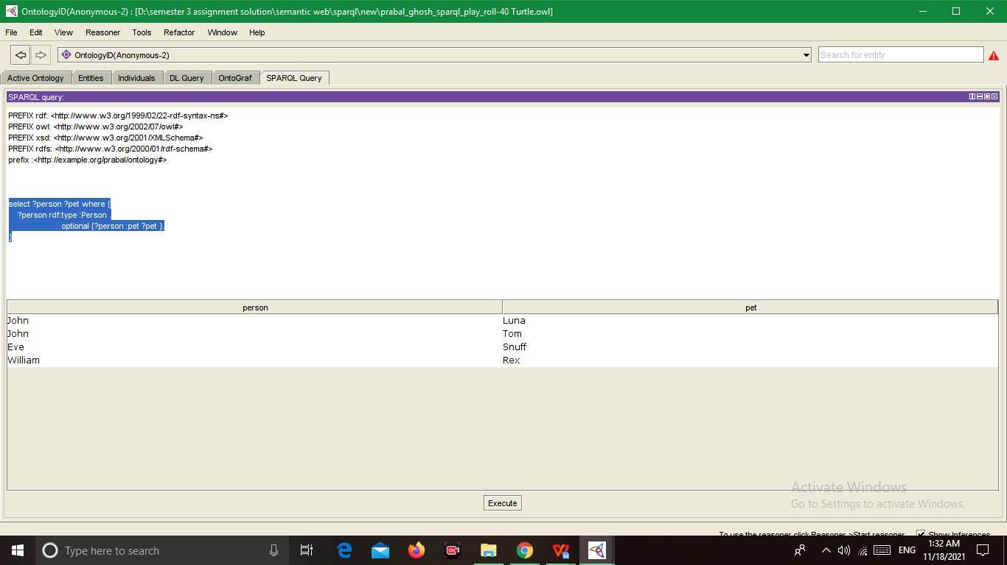

208)

select ?person ?pet where {

?person rdf:type :Person .

filter not exists {?person :pet ?pet }.

}

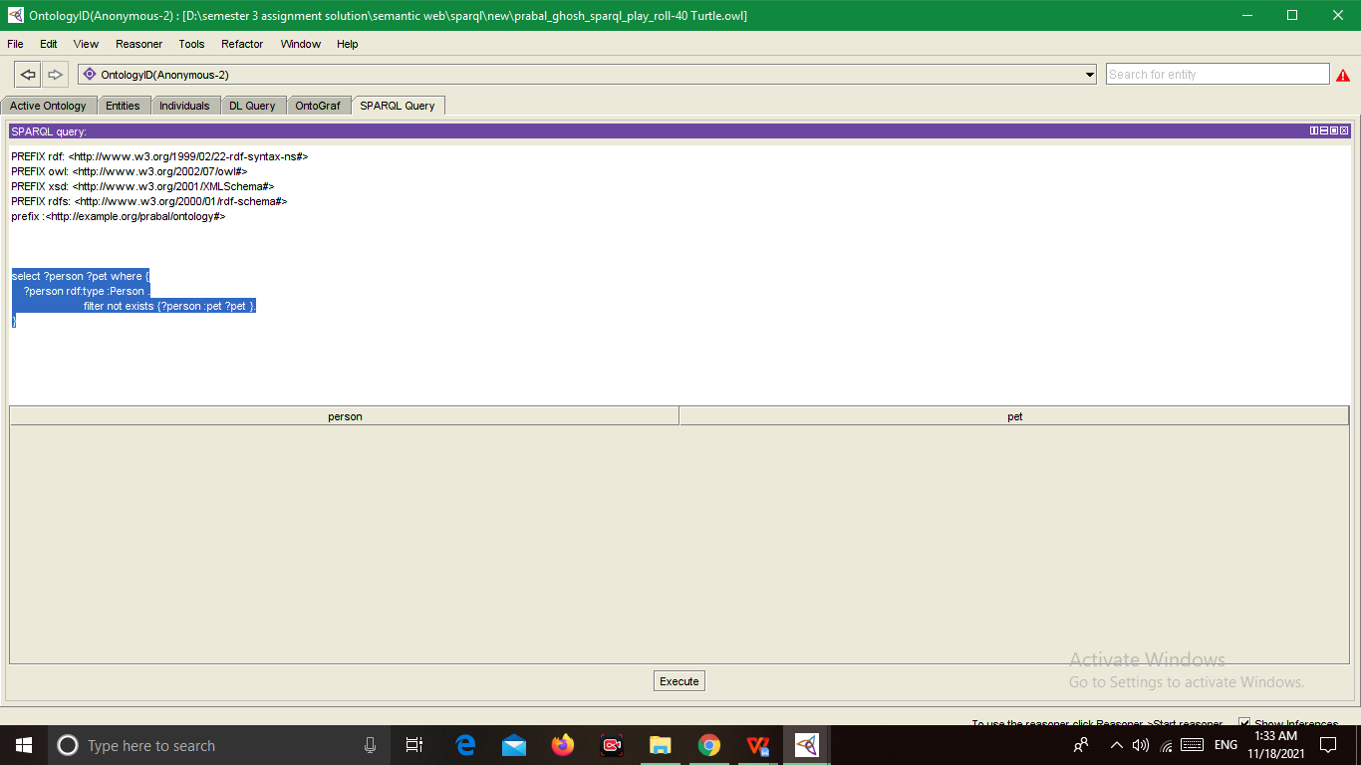

208)

select ( COUNT(?person) AS ?person ) where {

?person rdf:type :Person .

filter not exists {?person :pet ?pet }.

}

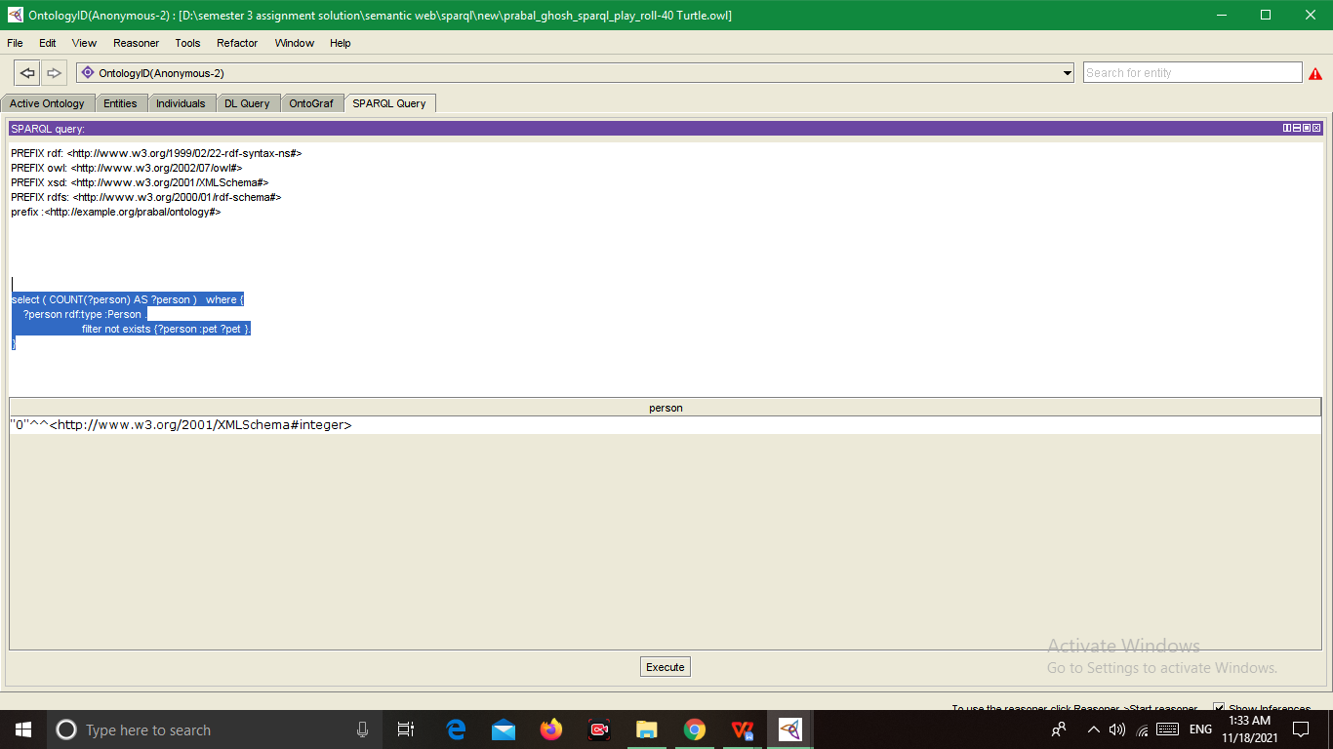

209)

select ?pet where {

{

:William :pet ?pet .

} UNION {

:John :pet ?pet .

}

}

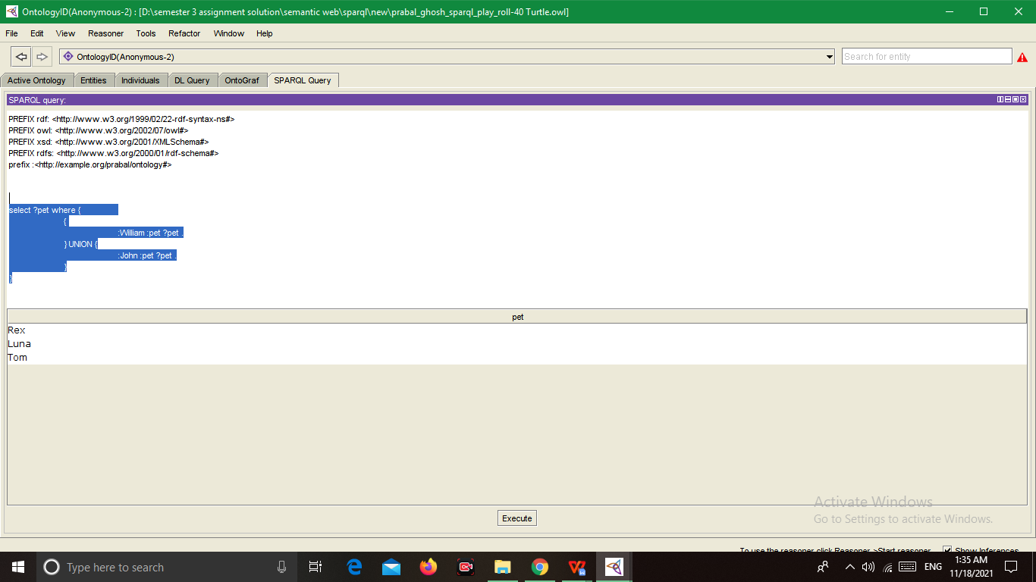

2) Write a SPARQL statement to find out: How many triplets are contained in the

dataset? Take a screenshot of the SPARQL code box and the output and paste in the

word file.

SELECT ( COUNT( ?S) AS ?S)

WHERE { ?S ?O ?P .}

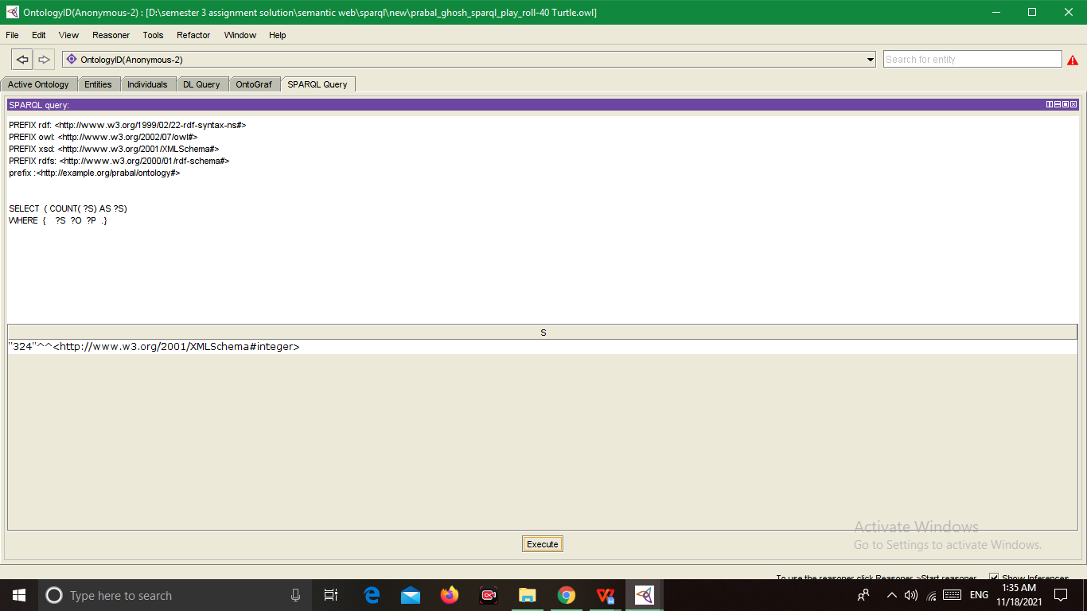

triplets are contained in the

Dataset ------

SELECT ?S ?O ?P

WHERE { ?S ?O ?P .}

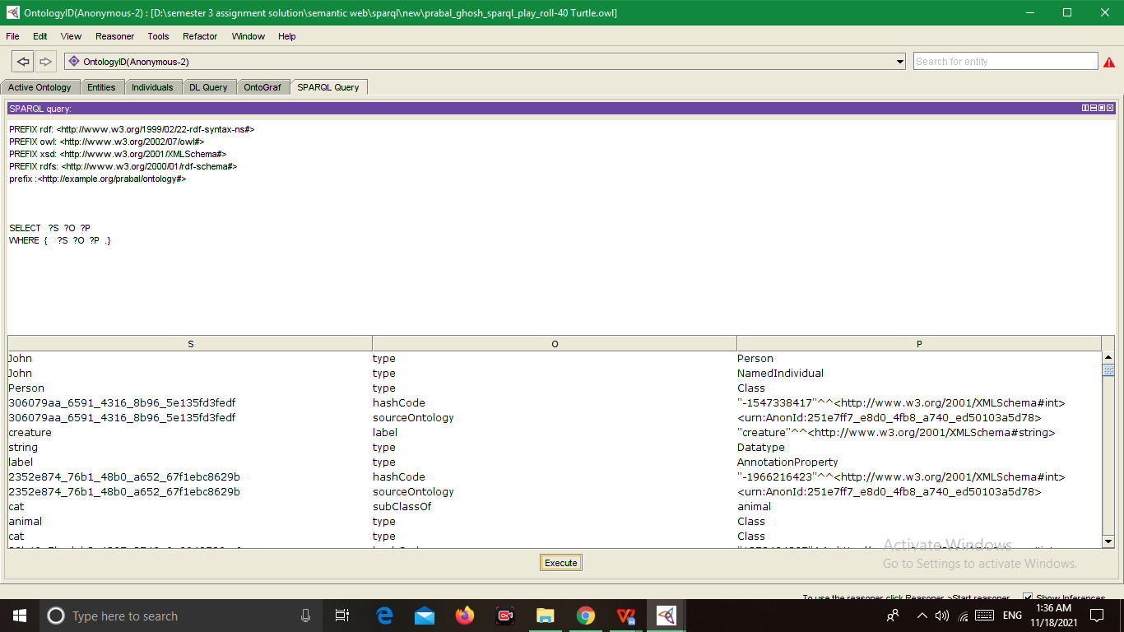

3.

Write a SPARQL statement to find out: How many instances of a “Animal” class are

declared? Take a screenshot of the SPARQL code box and the output and paste

below.

select ?x

where{

{?x rdf:type :Cat .

}

UNION

{ ?x rdf:type :Monkey.

}

UNION {?x rdf:type :Dog.

} }

